A Statistical and Non-linear Analysis of Electroencephalographic Signals

MSc Data Science, University of Aberdeen
2023/2024

Abstract

Electroencephalography is a method to measure the electrical activity in the brain using electrodes attached to the scalp (EEG (Electroencephalogram) - Mayo Clinic, 2022). The EEG is classified into EEG waveforms using the frequency range. The most common frequency bands include delta (0.4 to 4 Hz), theta (4 to 8 Hz), alpha (8 to 13 Hz), beta (13 to 30 Hz), and gamma (greater than 30 Hz) (Nayak & Anilkumar, 2023). EEG is a method used in Polysomnography, which refers to a systematic process used to collect physiologic parameters during sleep (Rundo & Downey, 2019). The frequency bands obtained in the EEG show different changes depending on the place of the brain the measuring is being taken and the state of Wakefulness or sleep (non-REM or REM) the person is in.
The main objective of this project is to use polysomnography to study the differences between the states of Wakefulness, non-REM, and REM based on the raw signals and the filtered signals obtained from one rat. To study the differences between the states of non-REM, REM, and Wakefulness, the raw signals of the channels passed through a process of preprocessing, feature extraction, and hypothesis testing. The principal test used to study the differences between the states was the Kruskal-Wallis test, which gave us results to understand which state was significantly different for the delta, theta, alpha, and beta signals, depending on the channel.

- Introduction
  - Electroencephalography and Polysomnography
Electroencephalography (EEG) is a technique that measures the fluctuations in electrical activity of the brain over a period. This electrical activity originates from the summed postsynaptic potentials of pyramidal neurons in the cerebral cortex (Read & Innis, 2017). EEG can be measured with electrodes placed on the scalp or directly on the cerebral cortex (called electrocorticogram or ECoG), this helps to acquire brain signals that correspond to various states. The amplitude of EEG in the wakefulness state is 10-100 uV, whereas for an ECoG amplitudes range from 500-1500 uV (Blinowska & Durka, 2006).
Polysomnography, also known as a sleep study, is a test used to “investigate the relationship among changes in physiology, impact on sleep, and consequences of waking function, performance, and behaviour” (Keenan, 2005). It records your brain waves (EEG), the oxygen level in the blood, and the heart rate and breathing during sleep, it can also measure the eye and leg movements, and it helps monitor your sleep stages and cycles (Polysomnography (sleep study), 2023).
The typical process of falling asleep begins with a sleep stage called non-rapid Eye Movement (non-REM), in this stage brain waves slow down (Polysomnography (sleep study), 2023), this stage can be divided into three substages:
- N1: is the transition from the stage of Wakefulness into sleep (Gerstenslager & Slowik, 2023). It is associated with the cessation of blinking and the absence of saccadic eye movements, the EMG activity level is lower compared to the Wakefulness stage (Pandi-Perumal, Spence & BaHammam, 2014).
- N2: Characterised by high tonic submental EMG levels and an absence of body movements (Pandi-Perumal et al., 2014).
- N3: considered the deepest stage of the non-REM stage. The brain becomes less responsive to external stimuli (Pandi-Perumal et al., 2014).
After around two hours, the brain activity increases, beginning the stage of Rapid Eye Movement (REM) sleep, this is the stage where dreaming occurs (Polysomnography (sleep study), 2023). Typically, a person goes through multiple sleep cycles at night.
The EEG plays an important role in identifying each stage during Polysomnography, it demonstrates several recognizable wave patterns from wakefulness through the sleep stages. In Table 1, we can see the state each frequency band signal is normally noticed and the location:
Table 1. Characteristics for each Electroencephalography frequency band signal (Delta, Theta, Alpha, Beta, and Gamma).
EEG waves | Characteristics
Delta | Seen in deep sleep, prominent in the frontocentral head regions (Nayak & Anilkumar, 2023).
Theta | Brought by drowsiness and early stages of sleep such as N1 or N2 (non-REM). Prominent in frontocentral head regions and slowly migrates backward, replacing alpha (Nayak & Anilkumar, 2023).
Alpha | Present in Wakefulness in the occipital regions. Best seen with eyes closed and mental relaxation (Nayak & Anilkumar, 2023).
Beta | Seen during states of concentration and problem-solving, tend to be more visible with eyes open (Beta Waves - Scottsdale Neurofeedback Institute, AZ, 2019). Prominent in the frontal and central head regions (Nayak & Anilkumar, 2023).
Gamma | Found during conscious perception, it is involved in attention, working memory, and long-term memory processes (Malik & Amin, 2017).

  - Objective and Process
The main objective of this project is to perform polysomnography on the datasets of the EEG channels provided and study the differences between the three stages we will be focusing on: Wakefulness, Non-Rapid Eye Movement (non-REM), and Rapid Eye Movement (REM). To achieve this, the data that was provided will go through:
- Preprocessing: use of Bandpass filters to obtain delta, theta, alpha, beta, and gamma signals.
- Perform Fast Fourier Transform (FFT) of the raw signals and their filtered signals.
- Feature extraction: obtain box plots and tables with the statistical features of the signals.
- Obtain histograms of the signals.
- Statistical hypothesis testing: perform the Anderson-Darling test to see if the signals follow a Gaussian distribution, the Kruskal-Wallis test to find differences between the states of non-REM, REM, and Wakefulness, and Kendall’s tau test to find correlations between the channels in each state.

- Data and Methods
  - Datasets
We will be referring to the datasets used in this project as Channels, each channel was obtained by registering the electroencephalographic activity of one rat implanted with electrodes to monitor sleep states (non-REM and REM) and Wakefulness. The electrodes were placed bilaterally on the skull above the primary motor cortex, primary somatosensory cortex, and secondary visual cortex, as well as in the olfactory bulb and cerebellum, this last electrode was used as the reference electrode (Torterolo et al., 2022). The location of each electrode can be seen in Figure 1 (Figure taken from Torterolo et al. (2022)).
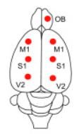
Figure 1. Location of the electrodes. Representation of the rat's brain showing the location of each of the electrodes used to register the raw signals. OB, olfactory bulb; M1, primary motor cortex; S1, primary somatosensory cortex; V2, secondary visual cortex. (Modified from (Torterolo et al., 2022))
Polysomnographic data were amplified (x1000), acquired, and stored in a computer using Dasy Lab Software employing 1024 Hz as a sampling frequency and 16 bits AD converter. The EEG channels were obtained by Cavelli et al. (2017), Cavelli et al. (2018), and Gonzalez et al. (2019).
Each recording given by one of the electrodes constitutes a Channel, having seven channels for each state, and 21 channels in total. For the Wakefulness state, each of the channels had 583,680 samples, whereas for the non-REM state, each channel had 694,2720 samples, and the REM channels had 1,290,240 samples.
In Figure 2, we can see how the raw data is visualised, in this case for the left primary motor cortex channel in the non-REM state, we can see that the amplitude of the signal is in millivolts (mV) and the length of time for this specific channel (above 6000 seconds).

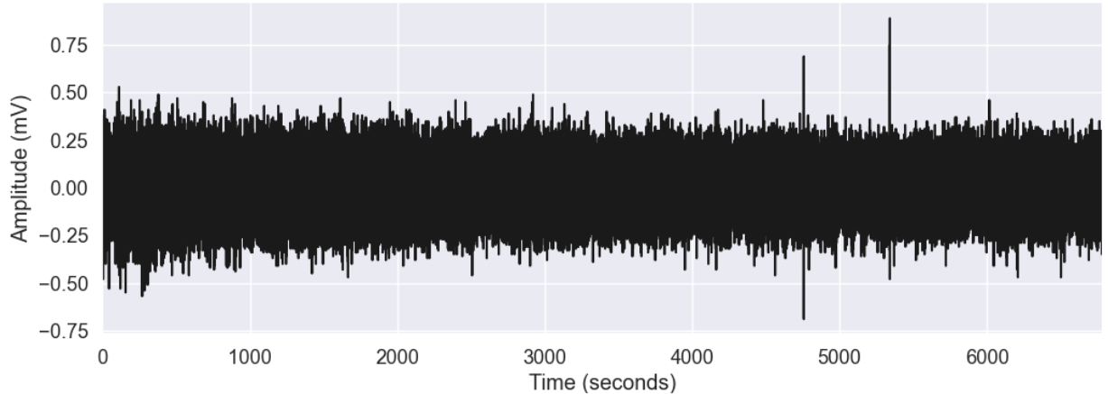
Figure 2. Raw signal of M1l_N channel. Visualization of the raw signal for the left primary motor channel in the non-REM state. Number of samples: 583,680; Sampling frequency: 1024Hz
  - Methods
The following methods were performed on each channel in each state.

    - Preprocessing of the data
The next step for the analysis of the EEG signal was the filtering of the raw data of each channel to obtain the delta, theta, alpha, beta, and gamma signals. For this step, we needed to use a filter, which is a signal processing system that suppresses unwanted components or features from a signal (DOO, n.d.). In this project, we used a band-pass filter, which is a filter that passes only the frequencies in a specific band while attenuating frequencies outside that range (Ahmad, 2023). In Figure 3 we can visualize the frequency response of a Bandpass filter, (Figure taken from Creating and Analyzing an RF Bandpass Filter Simulation (2019)).

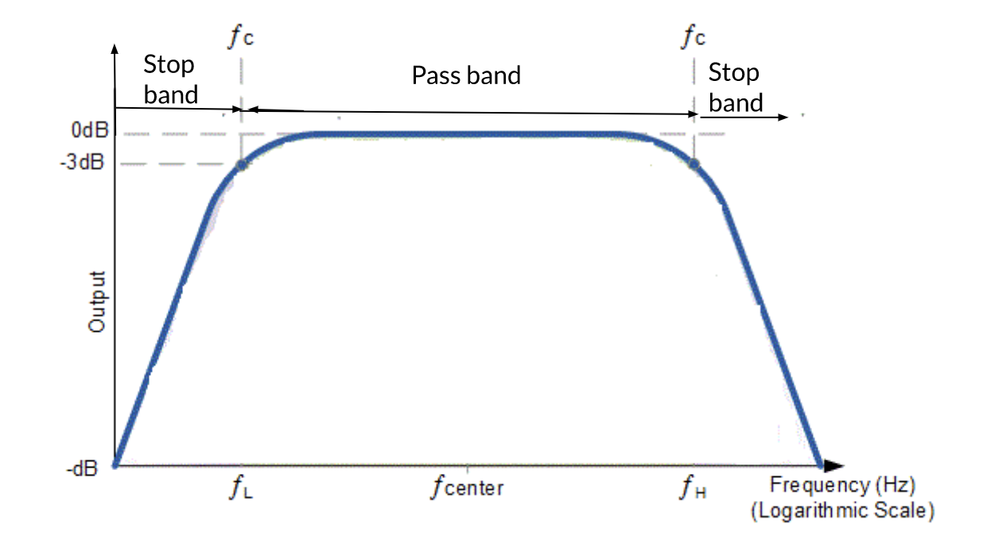
Figure 3. Bandpass Filter Frequency Response. Visualization of the frequency response of a bandpass filter. The filter has two frequency cutoffs (f_{c}), the low-frequency cut-off (fL) and the high-frequency cut-off (fH), to define the pass band and the stop bands. (Creating and Analyzing an RF Bandpass Filter Simulation, 2019)
We decided that a Butterworth bandpass filter of order 2 would be used. For the creation of the Butterworth bandpass filter in Python, we used the SciPy library, with the signal toolbox. First, we calculated the Nyquist frequency which is half of the sampling frequency, in this case, 512 Hz, then we divided the low and high cutoff frequencies by the Nyquist frequency, and with these values, we were able to design the Butterworth bandpass filter to obtain the different frequency bands. In Table 2, we can observe the frequencies we used as low and high frequencies cutoffs to obtain the frequency signals.
Table 2. Frequency cut-offs for the Butterworth bandpass filter to obtain delta, theta, alpha, beta, and gamma signals.
Frequency signal | Low-frequency cut-off (f_{L}) | High-frequency cut-off (f_{H})
Delta | 0.5 Hz | 4 Hz
Theta | 4 Hz | 8 Hz
Alpha | 8 Hz | 13 Hz
Beta | 13 Hz | 30 Hz
Gamma | 30 Hz | 510 Hz

    - Fast Fourier Transform
Our next step was to perform the Fast Fourier Transform (FFT) for the raw signal and its filtered signals, to measure their frequency content. A Hamming window was used to shape the time portion of the data and minimize the effect that could result in spectral leakage (Software Filtering: Windowing - General Analog Concepts, 2006). We multiplied each signal with the Hamming window and proceeded to apply the FFT to each of them. We took only the positive frequency values and the magnitudes of the corresponding FFT values. To obtain the Fast Fourier Transform in Python, we used the SciPy library for the FFT, and the Numpy library to obtain the Hamming window.
    - Feature extraction
Box and Whisker plot
We proceeded to extract time-domain features of the frequency band signals. As we needed a tool to summarize the data, see how it is distributed, and if the signal had any outliers, we opted to use a box and whisker plot. To be able to plot the box plots in Python, we used the matplotlib library, with the Pyplot sub-module.
The box plot displays the following:
- Minimum: the smallest value in the dataset excluding outliers (Box Plot Review (Article) | Khan Academy, n.d.). Represented with the bottom whisker, calculated as 1.5 * Interquartile range (IQR) (Box plot, n.d.).
- First quartile (Q1): “median of the data points to the left of the median” (Box Plot Review (Article) | Khan Academy, n.d.).
- Median (or Q2): found by ordering all data points and taking the one in the middle. In case there are two middle numbers, we take the mean of those two numbers (Mean, Median, and Mode Review (Article) | Khan Academy, n.d.).
- Third quartile (Q3): “The median of the data points to the right of the median” (Box Plot Review (Article) | Khan Academy, n.d.).
- Maximum: the largest data point excluding outliers (Box Plot Review (Article) | Khan Academy, n.d.). Represented with the upper whisker, calculated as 1.5 * Interquartile range (IQR) (Box plot, n.d.).
It also shows outliers, which are defined as “an observation that is numerically distant from the rest of the data” (Mcleod, 2023). To plot a box and whiskers plot, first, we draw a box from the first quartile to the third quartile, then a vertical line goes through the box at the median, and the whiskers go from each quartile to the minimum or maximum (Box Plot Review (Article) | Khan Academy, n.d.). The values that fall above or below the end of the whiskers are plotted as dots, these are the outliers (Box plot, n.d.). In Figure 4, we can visualize the different components of a box plot.
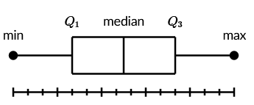
Figure 4. Example of a Box and Whisker Plot. Visualization of the minimum, first quartile (Q1), median, third quartile (Q3), and maximum in a boxplot (Box plot review (article) | Khan Academy, n.d.)

Table with statistical descriptors
Once we visualised the components of each filtered signal, we obtained a table with the statistical descriptors of the raw signal and its filtered signals to visualise them with numerical values and be able to understand the signal better. To obtain the table with the statistical descriptors in Python we used the describe() function.

The statistical descriptors we obtained of each raw signal and its filtered signals were:
- Count: number of samples in the datasets.
- Mean: “quantity that has a value intermediate between those of the extreme members of some set” (The Editors of Encyclopaedia Britannica, 2024).
- Standard deviation: “measure of how dispersed the data is in relation to the mean” (Finding and Using Health Statistics, n.d.). The following formula is used to obtain the standard deviation:
$$σ= \sqrt{\frac{\sum{{(x_{i}-μ)}^{2}}}{N}}$$
Where $σ$ is the standard deviation, x_{i} is each data point in a set, $μ$ is the mean, and N is the total count of data points (Finding and Using Health Statistics, n.d.).
- Minimum: minimum value in the dataset.
- First quartile (25%): “value under which 25% of data points are found when they are arranged in increasing order” (Government of Canada, Statistics Canada, 2021).
- Median: found by ordering all data points and taking the one in the middle (Mean, Median, and Mode Review (Article) | Khan Academy, n.d.).
- Third quartile (75%): “value under which 75% of data points are found when arranged in increasing order” (Government of Canada, Statistics Canada, 2021).
- Maximum: maximum value in the dataset.

    - Histograms
To obtain histograms of the raw signals and their filtered signals we used Doane’s formula to calculate the number of bins the histogram would have. The following is the Doane’s formula:
$$k=1+ \log_{2}\left(n\right)+ \log_{2}(1+ \frac{s}{σ_{s}})$$
Where n is the sample size, s is the estimated skewness of the variable distribution and:
$$σ_{s}= \sqrt{\frac{6(n-2)}{(n+1)(n+3)}}$$
To determine if the data follows a Gaussian distribution, the histogram would be bell-shaped, with one peak, and symmetric around the mean (Learn More About Normal Distribution | Dietary Assessment Primer, n.d.).
To be able to plot the Histograms in Python we used the Matplotlib library, with the Pyplot sub-module. We also used the Numpy library to use Doane’s formula to obtain the number of bins in each histogram.

    - Anderson Darling Test
To determine if the data came from a specific distribution, in this case, a Normal or Gaussian Distribution, we used the Anderson-Darling Test. Its hypotheses are:
- H₀: The data follows the specified distribution.
- H₁: The data does not follow the specified distribution.
To obtain the Anderson-Darling test results in Python we used the SciPy library with the sub-module stats. In Python, the Anderson-Darling test gives two important outputs to interpret the result, the first is the Anderson-Darling test statistic and the second one is significance levels for the corresponding critical values in percent. If the statistic value is larger than the critical values for the corresponding significance level, the null hypothesis can be rejected (Scipy.Stats.Anderson — SciPY v1.12.0 Manual., n.d.). For this project, a significance level of 5% was chosen. If the Anderson-Darling test statistic was greater than the critical value at the significance level of 5%, we rejected the null hypothesis that the signal followed a Gaussian distribution.

    - Kendall Tau Test
To understand how strong a relationship between channels in each state is, we used Kendall’s tau test. To obtain the Kendall’s tau test results in Python we used the SciPy library with the sub-module stats. In Python, the test returns the tau statistic and the p-value. The tau statistic is a correlation measure, values close to 1 indicate strong agreement, whereas values close to -1 indicate strong disagreement (Scipy.Stats.kendalltau — SciPy v1.12.0 Manual, n.d.). The p-value represents the chance of seeing our results if there was no actual relationship between the variables, a p-value less than or equal to 0.05 means the result is statistically significant (Kendall’s Tau - StatsTest.com, 2020). For this project, we applied Kendall’s tau test to measure the relationship between the raw signal of each of the channels in a state.

    - Kruskal Wallis Test
Once we defined if the signals followed a Gaussian distribution, we performed the Kruskal-Wallis test to determine if there were statistically significant differences between two or more of the signals. To obtain the Kruskal-Wallis test results in Python we used the SciPy library with the sub-module stats.
The test hypotheses are:
- H₀: The population medians are equal (McClenaghan, 2023).
- H₁: The population medians are not equal (McClenaghan, 2023).
For this test we chose a significance level of 0.05, if the p-value was smaller than the significance level, we rejected the null hypotheses and assumed that there were statistically significant differences between the chosen signals.

- Results
The first result obtained was the filtered signals for each of the channels in each of the states (REM, non-REM, and Wakefulness). In Figure 5 we can see the filtered signals obtained after we used the Butterworth bandpass filter on the left primary motor channel (M1L) in the non-REM state.

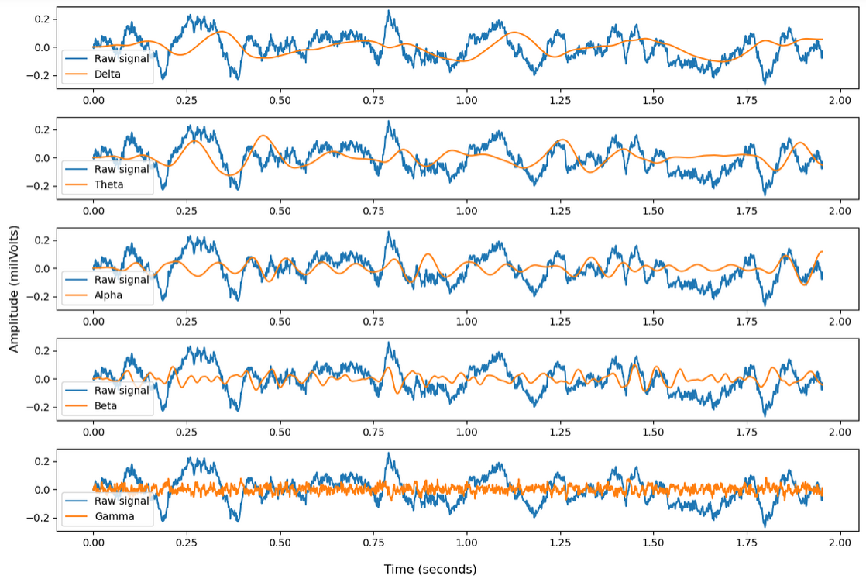
Figure 5. Comparison between EEG raw signal and its frequency bands. Visualization of the first 2000 samples of the raw signal (blue) and (from top to bottom) its Delta (0.5-4 Hz), Theta (4-8 Hz), Alpha (8-13 Hz), Beta (13-30 Hz), and Gamma (30-510 Hz) bands for the left primary motor channel (M1L) in the non-REM state, with a sampling frequency of 1024 Hz, using a Butterworth Bandpass Filter order 2.
As shown in Figure 5, the lower the frequency range the higher the amplitude of the signal and the longer the wavelength. For example, the delta signal has a higher amplitude but moves slower than the gamma signal, whose amplitude is smaller, and the wavelength is also smaller.
The next step was to obtain the Fast Fourier Transform of the raw signals and its filtered signals. This helped us determine if the Butterworth bandpass filter filtered the signals correctly by observing if the FFT of the filtered signals overlapped and matches the FFT of the raw signal. We can observe a comparison between the FFT of the raw signal for the left primary motor channel (M1L) for the non-REM state and the FFT of each of its filtered signals in Figure 6.

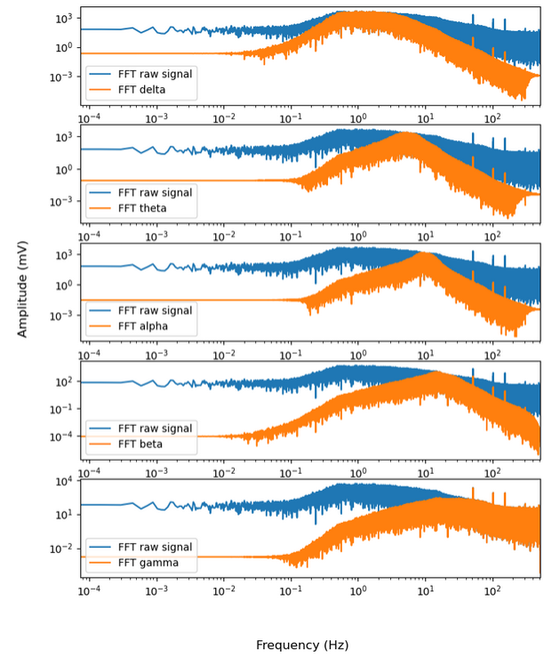
Figure 6. Comparison between the FFT of the raw signal and the FFT of its filtered signals. Visualisation of the FFT of the raw signal (blue) of the left primary motor cortex channel in the non-REM state versus the FFT of each of its filtered signals (from Top to bottom: Delta, Theta, Alpha, Beta, and Gamma). Sampling frequency (f_{s}): 1024 Hz, Number of samples (N): 694,2720.
We can observe in Figure 6 that the peak FFT of the filtered signals (in orange) matches the FFT of the raw signal (in blue) in their respective frequency ranges, meaning the Butterworth bandpass filter filtered the raw signals correctly.
We continued with the feature extraction in the time domain. The first step was to obtain the box plots to summarize the raw signals and their filtered signals. In Figure 7, we can see the box plots of the raw signal and its filtered signals for the left primary motor channel (M1L) for the non-REM state.
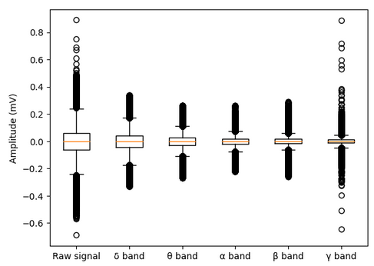
Figure 7. Box plot of the raw signal of the M1L channel and its filtered signals. Visualization of the box plots of the Raw signal, Delta, Theta, Alpha, Beta, and Gamma signals (from left to right) obtained from the left motor cortex channel (M1L) in the non-REM state.
As we can see, the six signals (raw and filtered) all have in common that their medians (orange line in the middle of the box) are around a value of zero. We can also observe that the interquartile range (IQR) diminishes from left to right, or as the frequency range increases.
We wanted to be able to know the exact values for each of the features of the signals, that’s why the next step in the time-domain feature extraction was to obtain the statistical values. We can observe the statistical values for the left primary motor cortex channel (M1L) in the non-REM state in Table 3.
Table 3. Statistical values for the raw signal and its filtered signals in the left primary motor cortex channel (M1L) in the non-REM state. The features we can observe are (from top to bottom) Number of samples (count), Mean, Standard deviation (std), Minimum value (min), First Quartile (25%), Median (50%), Third Quartile (75%) and Maximum value (max).
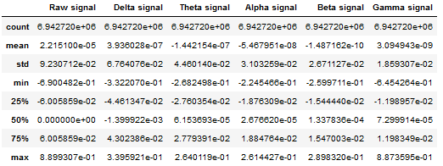

From Table 3 we can see that the raw signal and its filtered signals have the same number of samples (as expected), with a mean, standard deviation, and median close to zero. We can also observe that the minimum (-6.45e⁻¹) and maximum (8.87e⁻¹) values for the gamma signal are close to the minimum (-6.9e⁻¹) and maximum (8.89e⁻¹) values of the raw signal, meaning at some point the gamma signal has almost the same amplitude as the raw signal.

One important result we obtained is that the data does not follow a Gaussian distribution. This can be observed in the Histograms obtained and the results provided by the Anderson-Darling Tests. First, we will discuss the Histograms. For the data to follow a Gaussian distribution, its Histogram should be bell-shaped, with only one peak, and symmetric around the mean (Learn More About Normal Distribution | Dietary Assessment Primer, n.d.). In Figure 8, we can observe the Histograms for the raw signal and its frequency band signals for the left secondary visual cortex channel (V2L) for the non-REM state where the three requirements (bell-shaped, one peak, and symmetric around the mean) were not met in every histogram.
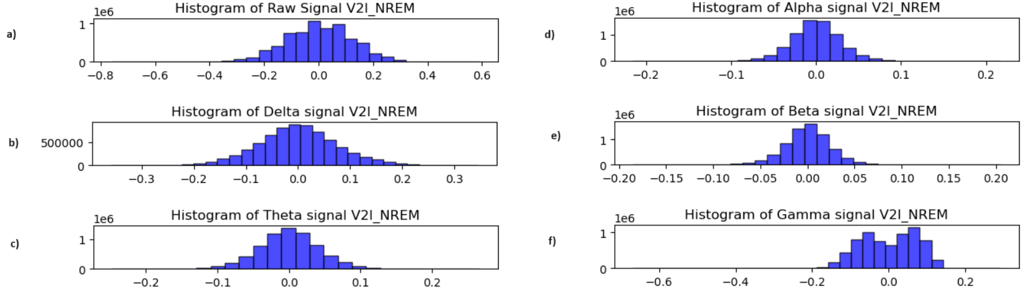
Figure 8. Histograms for the signals in the left secondary visual cortex channel in the non-REM state. Visualization of the histograms using Doane’s formula to calculate the number of bins. a) Histogram for the raw signal (bins = 31), b) Histogram for the delta signal (bins = 32), c) Histogram for the theta signal (bins = 27), d) Histogram for the alpha signal (bins = 29), e) Histogram for the beta signal (bins = 31), f) Histogram for the gamma signal (bins = 33).
As we can see in Figure 8, the raw and gamma signals have more than one peak, and the alpha, beta, and gamma signals are not symmetric around the mean. Only the delta and theta signals appear to meet the three requirements (bell-shaped, one peak, and symmetric around the mean).
The same was observed for the states of REM and Wakefulness. In Figure 9 and Figure 10, we can observe the histograms obtained for the raw signal and its frequency band signals of the left secondary visual cortex channel in the REM and Wakefulness state, respectively.
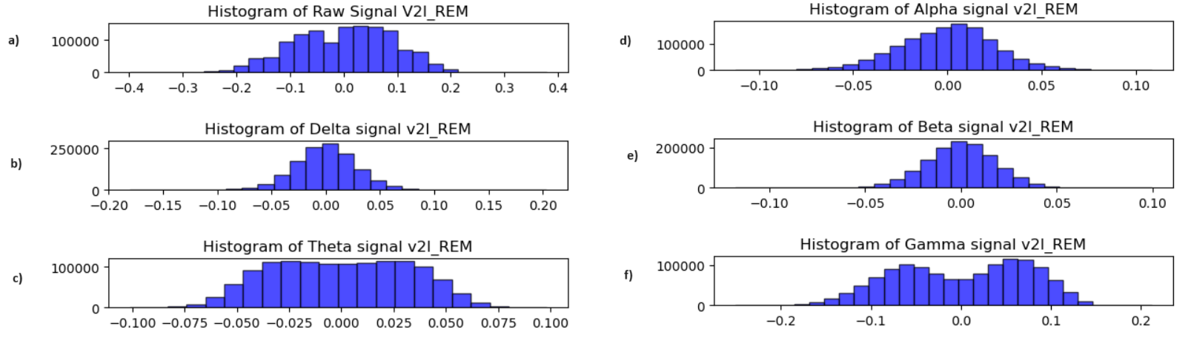
Figure 9. Histograms for the signals in the left secondary visual cortex channel in the REM state. Visualization of the histograms using Doane’s formula to calculate the number of bins. a) Histogram for the raw signal (bins = 29), b) Histogram for the delta signal (bins = 27), c) Histogram for the theta signal (bins = 23), d) Histogram for the alpha signal (bins = 28), e) Histogram for the beta signal (bins = 28), f) Histogram for the gamma signal (bins = 29).

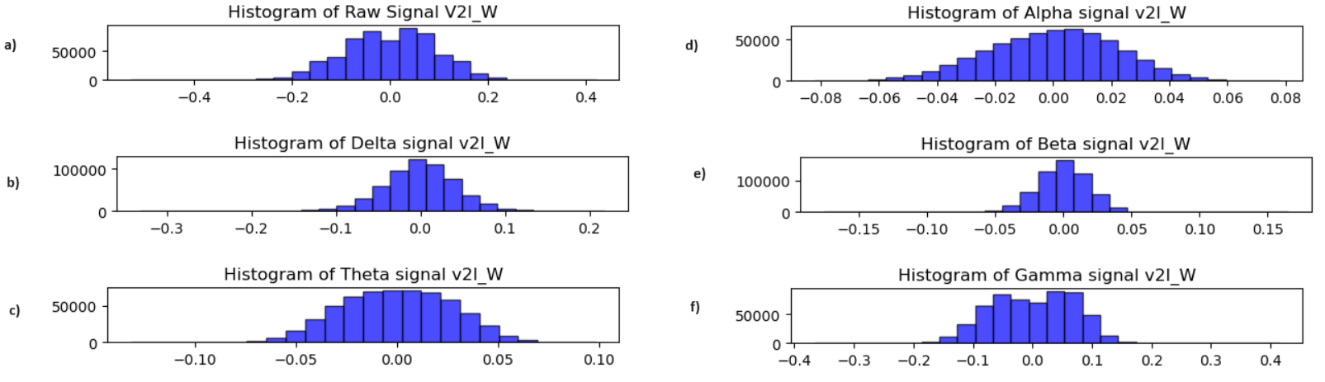
Figure 10. Histograms for the signals in the left secondary visual cortex channel in the Wakefulness state. Visualization of the histograms using Doane’s formula to calculate the number of bins. a) Histogram for the raw signal (bins = 27), b) Histogram for the delta signal (bins = 27), c) Histogram for the theta signal (bins = 25), d) Histogram for the alpha signal (bins = 27), e) Histogram for the beta signal (bins = 27), f) Histogram for the gamma signal (bins = 27).
As we can see, in the REM state, only the delta and beta signals seem to meet the three requirements (one peak, bell-shaped, and symmetric around the mean) to be considered a Gaussian distribution, the raw signal, alpha, and gamma signals are not symmetric around the mean, and the raw signal, theta, and gamma signals have more than one peak.
In the Wakefulness state, the delta, theta, and beta signals seem to meet the three requirements (one peak, bell-shaped, and symmetric around the mean), the alpha and gamma signals are not symmetric around the mean, and the raw and gamma signals have more than one peak. Similar results were observed in the rest of the channels, for the different states.

Although some signals seemed to follow the Gaussian distribution in the Histograms, the Anderson-Darling test gave us clear results that this was not true. As mentioned before, if the Anderson-Darling test statistic was greater than the critical value at the significance level of 5%, we rejected the null hypothesis that the signal followed a Gaussian distribution. For the raw signals and the filtered signals of each channel in each state, the critical value at the significance level of 5% was 0.787. As we can see in Table 4, the raw signal and its filtered signals for the non-REM state all have a statistic value greater than the critical value of 0.787, meaning none of the signals follow a Gaussian distribution. The results of the Anderson-Darling test for the states of REM and Wakefulness can be seen in Table 1 and Table 2 of the Supplementary Material, where we can also see all statistics values were greater than 0.787.

Table 4. Results for the Anderson-Darling test for the signals of the Olfactory Bulb (OB), Primary Left Motor Cortex (M1L), Primary Right Motor Cortex (M1R), Primary Left Somatosensory Cortex (S1L), Primary Right Somatosensory Cortex (S1R), Secondary Left Visual Cortex (V2L), Secondary Right Visual Cortex (V2R) in the non-REM state.
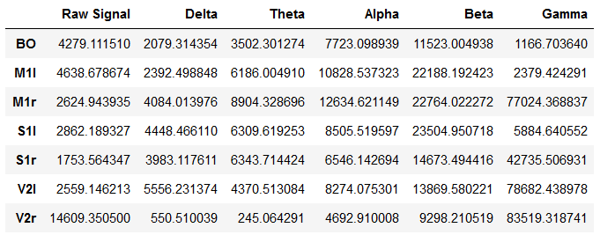

Next, Kendall’s tau test was performed to show how strongly the channels in each state are correlated. In Tables 5, 6, and 7, we can see Kendall’s tau test results for the non-REM, REM, and Wakefulness (respectively), with colours close to yellow meaning a strong positive correlation, and colours close to purple, meaning a negative correlation. The results show that every channel has a negative correlation with the olfactory bulb (OB) channel. We can also notice that the closer the electrodes are, the stronger the correlation coefficient is. To determine if the tau results are significant, we obtained the p-values, if the p-value was smaller than 0.05 we conclude that the tau result is significant. For this project every p-value was close to zero or zero, this can be observed in Tables 3, 4, and 5 of the Supplementary Material.

Table 5. Heatmap of Kendall's tau results for the channels in the non-REM state. BO_N, Olfactory Bulb; ML_N, left primary motor cortex; MR_N, right primary motor cortex; SL_N, left primary somatosensory cortex; SR_N, right primary somatosensory cortex; VL_N, left secondary visual cortex, VR_N, right secondary visual cortex.
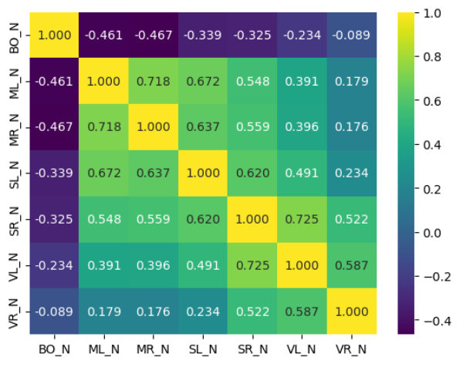
Table 6. Heatmap of Kendall's tau results for the channels in the REM state. BO_R, Olfactory Bulb; ML_R, left primary motor cortex; MR_R, right primary motor cortex; SL_R, left primary somatosensory cortex; SR_R, right primary somatosensory cortex; VL_R, left secondary visual cortex, VR_R, right secondary visual cortex.
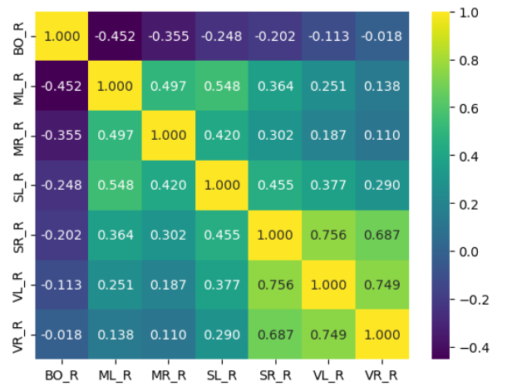
Table 7. Heatmap of Kendall's tau results for the channels in the Wakefulness state. BO_W, Olfactory Bulb; ML_W, left primary motor cortex; MR_W, right primary motor cortex; SL_W, left primary somatosensory cortex; SR_W, right primary somatosensory cortex; VL_W, left secondary visual cortex, VR_W, right secondary visual cortex.
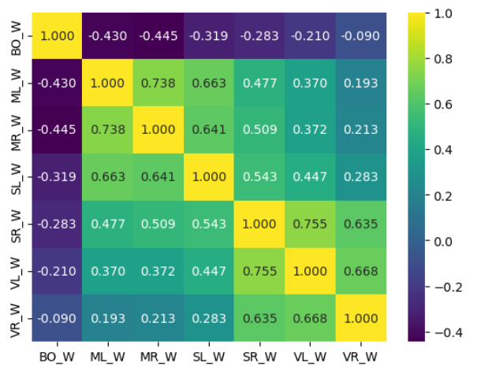

Next, the Kruskal-Wallis test was performed in each frequency band signal of each channel, to determine if the three states (non-REM, REM, and Wakefulness) were significantly different from each other. If the p-value was smaller than the significance level of 0.05, meant that there were significant differences between the three states. The results showed that for the left and right primary motor cortex (M1L and M1R), the delta signals were the only ones with a p-value smaller than 0.05. For the olfactory bulb channel (OB) and the left primary somatosensory cortex channel (S1L), the delta, theta, alpha, and beta signals had a p-value smaller than 0.05. For the left and right secondary visual cortex channels (V2L and V2R) and the right primary somatosensory channel (S1R), the delta and alpha signals had a p-value smaller than 0.05. The results can be observed in Table 8, with p-values smaller than the significance level of 0.05 in orange.

Table 8. Kruskal-Wallis test p-values for the frequency band signals of the channels, between the states of non-REM, REM, and Wakefulness. P-values smaller than 0.05 are in orange and p-values greater than 0.05 are in black. OB, Olfactory Bulb; M1L, left primary motor cortex; M1R, right primary motor cortex; S1L, left primary somatosensory cortex; S1R, right primary somatosensory cortex; V2L, left secondary visual cortex, V2R, right secondary visual cortex.
 | OB | M1L | M1R | S1L | S1R | V2L | V2R
Delta | 3.031e⁻¹⁶⁹ | 1.96e⁻¹²⁸ | 2.95e⁻²²⁰ | 1.44e⁻²⁵⁹ | 5.77e⁻¹⁵¹ | 7.69e⁻¹⁹⁶ | 2.11e⁻⁹
Theta | 0.027 | 0.0897 | 0.372 | 0.023 | 0.496 | 0.423 | 0.915
Alpha | 2.54e⁻⁷ | 0.259 | 0.830 | 2.17e⁻¹⁶ | 1.49e⁻²¹ | 4.94e⁻⁵³ | 2.72e⁻⁷⁴
Beta | 4.03e⁻⁴ | 0.375 | 0.147 | 0.041 | 0.099 | 0.187 | 0.366
Gamma | 0.56 | 0.868 | 0.397 | 0.201 | 0.225 | 0.822 | 0.743

After obtaining the results shown in Table 8, we again applied the Kruskal-Wallis test to the frequency bands with p-values smaller than 0.05 (in colour orange in Table 8) to determine which of the states (non-REM, REM, or Wakefulness) were statistically different. The results show that in the Olfactory Bulb channel for the delta and alpha signals, the three channels were significantly different from each other, whereas, for the beta signals, the Wakefulness state was significantly different. In the left primary motor cortex for the delta signal, the significantly different state was the non-REM state. In the right primary motor cortex for the delta signal, all states were significantly different from each other. In the left primary somatosensory cortex for the delta and alpha signals, the significantly different state was the non-REM state. In the right primary somatosensory cortex for the delta signal, the three states were significantly different from each other, whereas for the alpha signal the significantly different state was the non-REM state. In both the left and right secondary visual cortex channels, for the delta and alpha signals, all three states were significantly different from each other. We can visualize this in Table 9, where we can see that for the theta signals in the Olfactory bulb (OB) channels, and the theta and beta signals in the left primary somatosensory cortex (S1L) channels it appears that the result was Indeterminate, this is because the Kruskal-Wallis test results were unable to determine which of the three states was the significantly different one. The numerical values for each of the Kruskal-Wallis tests to determine which state was significantly different are available in Tables 6, 7, 8, and 9 of the Supplementary Material.

Table 9. Results of which state is statistically different, using the Kruskal-Wallis test, comparing the delta signals for the olfactory bulb (OB), the left and right primary motor cortex (M1L and M1R), the left and right primary somatosensory cortex (S1L and S1R), and the left and right secondary visual cortex channels (V2L and V2R).
 | OB | M1L | M1R | S1L | S1R | V2L | V2R
Delta | ALL | NREM | ALL | NREM | ALL | ALL | ALL
Theta | Ind. | N/A | N/A | Ind. | N/A | N/A | N/A
Alpha | ALL | N/A | N/A | NREM | NREM | ALL | ALL
Beta | W | N/A | N/A | Ind. | N/A | N/A | N/A

We can see from Table 9, that especially towards the occipital part of the brain (visual cortices) for the delta and alpha signals, every state is different from the other, and the non-REM state is persistent in the central parts of the brain (motor and somatosensory cortices).

- Discussion
In this project, we managed to filter the raw signals of each channel and extract the features of each of them, we also obtained the correlations between the channels in each state, but our main objective was to compare the states of non-REM, REM, and Wakefulness, which was done with the Kruskal Wallis test.

The Kruskal-Wallis test result showed that the states in the delta signals were significantly different in every channel, showing that all states in each channel were significantly different from each other, except for the left primary motor cortex channel (M1L) and right primary somatosensory cortex channel (S1R), where the non-REM state was the one significantly different from the others. According to Memar & Faradji (2017), delta signals are more noticeable in the non-REM state, specifically in the frontocentral part of the brain (Nayak & Anilkumar, 2023), which is comparable with the results in Table 9 for the left primary motor and right primary somatosensory channels.
From Table 9 we can also analyse the results for the alpha signals, where significant difference appears mostly towards the occipital areas. According to Memar & Faradji (2017), alpha signals are noticeable in the early stages of the non-REM state and during Wakefulness in the occipital head regions, where the left and right secondary visual cortices are located.
For the beta signals, the Wakefulness state was significantly different from the other states, which according to Memar & Faradji (2017) beta is more noticeable in the Wakefulness state in the frontocentral part of the brain where the olfactory bulb is located.
We can also notice from Table 8, that the only signal that appears to give Kruskal-Wallis p-values greater than 0.05 are the gamma signals, in every channel the states are statistically similar, this is comparable to the results obtained by Memar & Faradji (2017) when they proposed a system to classify the sleep stages, the gamma band could not prove its significance in their overall system performance.

Future research could include EEG datasets from other rats, to see how the filtered signals change between each rat and analyse if there are differences between the states of non-REM, REM, and Wakefulness, using the Kruskal-Wallis test. It could also compare the use of other types of bandpass filters, for example, the Finite Impulse Response (FIR) filter or Chebyshev filter, to see if these filters produce better-filtered signals, analysing the results with FFT again. The next steps in analysing the data could include creating surrogate signals to continue performing statistical hypothesis testing, as well as creating phase portraits by combining bands.

- References
  - EEG (electroencephalogram) - Mayo Clinic. (2022, May 11). https://www.mayoclinic.org/tests-procedures/eeg/about/pac-20393875
  - Rundo, J. V., & Downey, R., 3rd (2019). Polysomnography. Handbook of clinical neurology, 160, 381–392. https://doi.org/10.1016/B978-0-444-64032-1.00025-4
  - Nayak, C. S., & Anilkumar, A. C. (2023b, July 24). EEG Normal waveforms. StatPearls - NCBI Bookshelf. https://www.ncbi.nlm.nih.gov/books/NBK539805/
  - Read, G. L., & Innis, I. J. (2017). Electroencephalography (Eeg). The international encyclopedia of communication research methods, 1-18.
  - Blinowska, K., & Durka, P. (2006). Electroencephalography (eeg). Wiley encyclopedia of biomedical engineering.
  - Keenan, S. A. (2005). An overview of polysomnography. Handbook of clinical neurophysiology, 6, 33-50.
  - Polysomnography (sleep study). (2023). Mayoclinic.org. https://www.mayoclinic.org/tests-procedures/polysomnography/about/pac-20394877
  - Beta Waves - Scottsdale Neurofeedback Institute, AZ. (2019, October 2). Scottsdale Neurofeedback Institute, AZ. https://scottsdaleneurofeedback.com/services/qeeg-brain-mapping/eeg-brainwaves/beta-waves/
  - Malik, A. S., & Amin, H. U. (2017). Designing an EEG experiment. In Elsevier eBooks (pp. 1–30). https://doi.org/10.1016/b978-0-12-811140-6.00001-1
  - Pandi-Perumal, S.R., Spence, D.W., BaHammam, A.S. (2014). Polysomnography: An Overview. In: Pagel, J., Pandi-Perumal, S. (eds) Primary Care Sleep Medicine. Springer, New York, NY. https://doi.org/10.1007/978-1-4939-1185-1_4
  - Gerstenslager, B., & Slowik, J. M. (2023). Sleep study. StatPearls - NCBI Bookshelf. https://www.ncbi.nlm.nih.gov/books/NBK563147/
  - Torterolo, P., Gonzalez, J., Castro-Zaballa, S., Cavelli, M., Mondino, A., Pascovich, C., Rubido, N., Murillo-Rodríguez, E., & Vanini, G. (2022). Polysomnography in humans and animal models: Basic procedures and analysis. Methodological Approaches for Sleep and Vigilance Research, 17-32. https://doi.org/10.1016/B978-0-323-85235-7.00010-7
  - Cavelli, M., Castro-Zaballa, S., Mondino, A., Gonzalez, J., Falconi, A., & Torterolo, P. (2017). Absence of EEG gamma coherence in a local activated cortical state: a conserved trait of REM sleep. Translational Brain Rhythmicity, 21132017. DOI: 10.15761/TBR.1000115
  - Cavelli, M., Rojas‐Líbano, D., Schwarzkopf, N., Castro‐Zaballa, S., Gonzalez, J., Mondino, A., ... & Torterolo, P. (2018). Power and coherence of cortical high‐frequency oscillations during wakefulness and sleep. European Journal of Neuroscience, 48(8), 2728-2737. DOI: 10.1111/ejn.13718
  - González, J., Cavelli, M., Mondino, A., Pascovich, C., Castro-Zaballa, S., Torterolo, P., & Rubido, N. (2019). Decreased electrocortical temporal complexity distinguishes sleep from wakefulness. Scientific reports, 9(1), 1-9. DOI: 10.1038/s41598-019-54788-6
  - DOO, D. (n.d.). Signal filtering, Signal suppression, Signal processing | Dewesoft. https://training.dewesoft.com/online/course/filters
  - Ahmad, A. (2023, July 27). How to create Bandpass filters. Technical Articles. https://eepower.com/technical-articles/how-to-create-bandpass-filters/#
  - Creating and analyzing an RF Bandpass filter simulation. (2019). https://resources.pcb.cadence.com/blog/2023-creating-and-analyzing-an-rf-bandpass-filter-simulation
  - Mcleod, S., PhD. (2023). Box Plot Explained: Interpretation, Examples, & Comparison. Simply Psychology. https://www.simplypsychology.org/boxplots.html
  - Box plot review (article) | Khan Academy. (n.d.). Khan Academy. https://www.khanacademy.org/math/statistics-probability/summarizing-quantitative-data/box-whisker-plots/a/box-plot-review
  - Mean, median, and mode review (article) | Khan Academy. (n.d.). Khan Academy. https://www.khanacademy.org/math/statistics-probability/summarizing-quantitative-data/mean-median-basics/a/mean-median-and-mode-review
  - Box plot. (n.d.). Introduction to Statistics | JMP. https://www.jmp.com/en_be/statistics-knowledge-portal/exploratory-data-analysis/box-plot.html
  - The Editors of Encyclopaedia Britannica. (2024). Mean | Definition, Formula, & Facts. Encyclopedia Britannica. https://www.britannica.com/science/mean
  - Finding and using health statistics. (n.d.). https://www.nlm.nih.gov/oet/ed/stats/02-900.html
  - Government of Canada, Statistics Canada. (2021, September 2). 4.5.1 Calculating the range and interquartile range. https://www150.statcan.gc.ca/n1/edu/power-pouvoir/ch12/5214890-eng.htm
  - Software Filtering: Windowing - General Analog Concepts. (2006, September 20). NI. https://www.ni.com/en/support/documentation/supplemental/06/software-filtering--windowing---general-analog-concepts.html
  - Learn More about Normal Distribution | Dietary Assessment Primer. (n.d.). https://dietassessmentprimer.cancer.gov/learn/distribution.html
  - Scipy.Stats.Anderson — SciPY v1.12.0 Manual. (n.d.). https://docs.scipy.org/doc/scipy/reference/generated/scipy.stats.anderson.html
  - McClenaghan, E. (2023, February 9). The Kruskal–Wallis Test. Informatics From Technology Networks. https://www.technologynetworks.com/informatics/articles/the-kruskal-wallis-test-370025
  - Scipy.Stats.kendalltau — SciPy v1.12.0 Manual. (n.d.). https://docs.scipy.org/doc/scipy/reference/generated/scipy.stats.kendalltau.html
  - Kendall’s Tau - StatsTest.com. (2020). StatsTest.com. https://www.statstest.com/kendalls-tau/
  - Memar, P., & Faradji, F. (2017). A novel multi-class EEG-based sleep stage classification system. IEEE Transactions on Neural Systems and Rehabilitation Engineering, 26(1), 84-95.

